DRAFT
Holonic Semantic Governance Architecture
HSGA · Reference Architecture
Version 5.0 · Draft · November 9, 2026
SECTION 1 Document control
Version, status, owner, companion and the versioning rules that govern this document.
SECTION 2 Version history
Dated record of every version and what changed, newest first.
SECTION 3 Purpose and scope
What HSGA is, what it covers and leaves out, and who reads which sections.
SECTION 4 Architecture at a glance
The scaffold over legacy systems, the end-to-end flow, design principles and the complete one-page architecture.
SECTION 5 Holonic structure
The seven-layer holarchy, the four governance domains and the lateral mediation holon.
SECTION 6 Semantic design and naming standard
Design invariants, asset types and tiers, naming, graph classes and IRIs, and the thirteen naming rules.
SECTION 7 Lexicon layer and customer terminology
Scoped lexicons and customer extensions for alternate labels, matching, triage, lifecycle and resolution.
SECTION 8 Tenancy, personas and access
Tenant isolation, repositories, personas, access decisions and provisioning.
SECTION 9 Semantic services and operations extensions
The twelve semantic services, capture and warehouse, publishing, and the operations extensions.
SECTION 10 Logic single source of truth
One declarative spec, generated executables, the Decision API and the migration path.
SECTION 11 Runtime governance
The seven-stage gateway, compiled governance, the eight agents and the human checkpoints.
SECTION 12 Measurement and assurance
MTBH, structural measures, lexicon-layer targets and lifecycle fit.
SECTION 13 Roadmap, decisions and risks
Programme phases, pilot gates, the decision register, risks and open questions.
SECTION 14 Maintenance guide
Change classes, amendment steps and conventions for keeping this document current.
SECTION 15 Sources and related documents
The source documents this version draws on.

Contents
SECTION 1 Document control
Versioning rules
SECTION 2 Version history
Changes in 5.0 that alter earlier statements
SECTION 3 Purpose and scope
SECTION 4 Architecture at a glance
4.1 Flow
4.2 Design principles
4.3 Complete architecture on one page
SECTION 5 Holonic structure
5.1 Layers
5.2 Four governance domains
5.3 Mediation holon
SECTION 6 Semantic design and naming standard
6.1 Design invariants
6.2 Types by tier
6.3 Asset names
6.4 Graph classes and IRIs
6.5 Naming rules
SECTION 7 Lexicon layer and customer terminology
7.1 Why labels do not live on the core
7.2 Principles
7.3 The label record
7.4 Matching and match relations
7.5 Triage
7.6 Label lifecycle, promotion and releases
7.7 Resolution
SECTION 8 Tenancy, personas and access
8.1 Repositories and topology
8.2 Isolation and privacy
8.3 Operational personas (proposed)
8.4 How access is decided
8.5 Provisioning
SECTION 9 Semantic services and operations extensions
9.1 The services
9.2 Capture and warehouse
9.3 Publishing to targets
9.4 Operations extensions
SECTION 10 Logic single source of truth
10.1 Right home by layer
10.2 Governance pipeline
10.3 Generated executables and the Decision API
10.4 Migration
10.5 Relation to compiled governance
SECTION 11 Runtime governance
11.1 Gateway stages (RDSG)
11.2 Compiled governance
11.3 Agents and loop
11.4 Human checkpoints
SECTION 12 Measurement and assurance
12.1 MTBH
12.2 Structural measures
12.3 Lexicon-layer targets
12.4 Lifecycle fit
SECTION 13 Roadmap, decisions and risks
13.1 Programme phases
13.2 Semantic services pilot and gates
13.3 Decision register
13.4 Risks and mitigations
13.5 Open questions
SECTION 14 Maintenance guide
14.1 Change classes
14.2 Amendment steps
14.3 Keep in step
14.4 Conventions
SECTION 15 Sources and related documents
Nov 9, 2026 · @jeffrey

SECTION 1

Document control
This is version 5.0, issued 2026-11-09, of the HSGA architecture, the first to fold the lexicon layer, the graph naming standard, tenancy and the logic single source of truth into the v4.2 reference architecture.
Item | Value
Document | Holonic Semantic Governance Architecture (HSGA)
Current version | 5.0, issued 2026-11-09; number proposed for a major change to the label model and asset taxonomy
Supersedes | v4.2, Reference Topology and Governance Diagram Edition
Owner | Jeffrey Wallk
Status | Issued for review, not yet reviewed by the governance council
Companion | HSGA Explorer, an interactive walkthrough of this document
Review cadence | Proposed: at each delivery gate (G0 21 Dec 2026, G1 8 Mar 2027, G2 3 May 2027, G3 24 May 2027) and on any change class below

Versioning rules
- Number. MAJOR.MINOR. A major change alters an invariant, the asset types or tiers, a MUST rule in the naming standard, or the service contract model. A minor change adds or extends a capability without breaking an invariant. Wording and correction fixes do not take a new number; record them in the version history as a revision note.
- Status. Draft, In review, Approved, Superseded. Only the council moves a version to Approved.
- History. Never edit a past row of the version history. Add a new row at the top.
- Decisions. Every open or proposed decision lives in the decision register (section 13). A version is not Approved while a decision it depends on is open.

SECTION 2

Version history
Version 5.0 is the newest row; add each later version above it.
Version | Date | Class | What changed | Sources
5.0 | 2026-11-09 | Major | Adds the lexicon layer (labels and customer terms in scoped graphs beside the core); five asset types and four tiers; the graph naming standard; tenancy, personas and access decisions; twelve semantic services; operations extensions (screens, monitoring, triage, simulation); the logic single source of truth; a complete one-page architecture diagram and five detailed breakdown diagrams (services, gateway, label resolution, logic pipeline). Core and domain terms keep preferred labels and a vetted universal set only. | Alternate Labels proposal (31 Oct 2026); Graph Naming Standard insert (1 Nov 2026); SSOT Logic Architecture
4.2 | not recorded | Minor | Reference topology and governance diagram edition: all seven holarchy layers, four governance domains, human-in-the-loop diagram set (Section 13 of v4.2). | HSGA v4.2
4.0 | not recorded | Minor | Reference topology and diagram set introduced. | HSGA v4.2
3.0 | not recorded | Major | Semantic Abstraction and Mediation Layer: mapping graph as a persistent lateral holon; compiled semantic governance; cross-silo entity and URI resolution; RAG grounding. | HSGA v4.2

Versions before 3.0 and the dates of 3.0 to 4.2 are not in the source documents. Fill them in if you hold them.

Changes in 5.0 that alter earlier statements
- Alternate, acronym, persona and hidden labels on core and domain terms are replaced by the vetted universal set; everything else moves to lexicons.
- Persona label graphs become scoped lexicons at the domain, enterprise or customer tier.
- The single-letter asset codes gain L (lexicon) and M (mapping).
- Tenant extensions are customer-tier vocabularies or taxonomies and are never ontologies.

SECTION 3

Purpose and scope
HSGA is a governed layer of shared meaning that sits on top of existing systems, binds what exists to agreed concepts, enforces rules once, and lets AI act within limits that people can audit. It is a semantic scaffold, not a replacement platform.
In scope
- The holonic structure and seven-layer holarchy, and the four governance domains.
- The semantic design: core, domain, enterprise and customer assets, with their naming.
- The lexicon layer for alternate labels and customer terminology.
- Tenant isolation, personas, access decisions and provisioning.
- The semantic services and the operations extensions built on them.
- The single source of truth for business logic.
- Runtime governance (gateway, compiled rules, agents) and measurement.

Out of scope
- Choice of graph store, identity provider, policy engine, telemetry platform and review-application host. The design is stack-independent; GraphDB is assumed only for sizing.
- The persona and job catalog, which Personas & Jobs owns.
- Customer data models in systems of record, which are bound, not changed.

Readers. Council members and domain stewards read sections 3 to 7 and 13. Engineers read sections 5 to 12. Operations leads read sections 8, 9 and 12.

SECTION 4

Architecture at a glance
HSGA is additive: new layers of mapping, shared meaning, scoped terminology, governance and delivery sit above the legacy estate, which is bound to concepts rather than replaced.
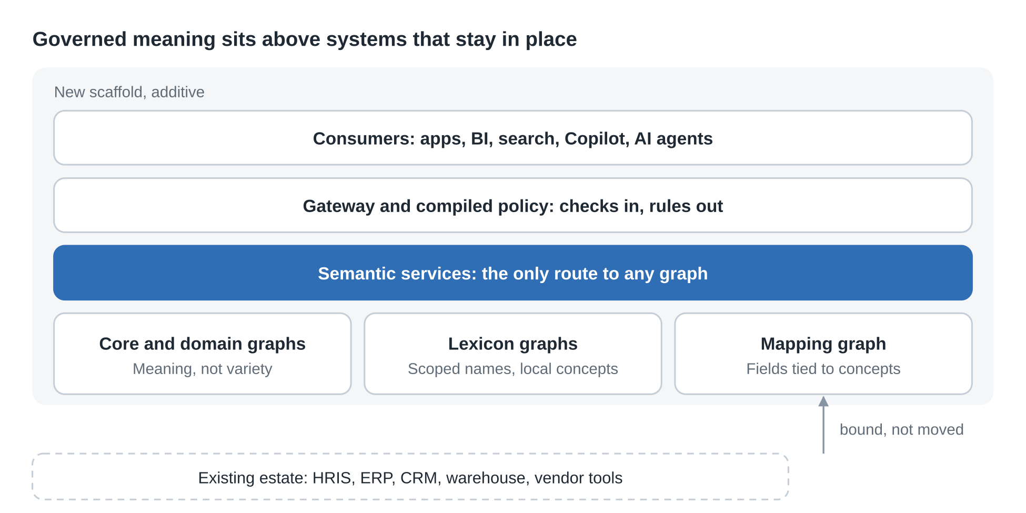
Figure 1. Scaffold over legacy: 4 new layers, 1 existing estate
Requests and AI actions pass the gateway, then the services, which are the only route to any graph. The mapping graph ties system fields to concepts without moving data.

4.1 Flow
- Bind and map. A mediation holon ties each system field to one agreed concept, with confidence scores and steward confirmation.
- Govern core and lexicons. A small immutable core carries meaning; scoped lexicons and customer extensions carry the many names.
- Check at the gateway. Every request and AI action passes seven stages.
- Compile and deliver. Rules are written once and compiled to data checks, access policy, search filters, agent guardrails and rules-engine artifacts; released vocabularies publish to targets such as Visier.
- Human and measurement spine. People decide what machines cannot; trust and structure are measured.

4.2 Design principles
- Add a layer; do not replace systems of record.
- Keep the core small: onboarding a customer adds no triples to it.
- Scope terminology by where it is stored, one named graph per tenant.
- Author each rule once and generate its runtime forms.
- Machines propose, people decide.
- Measure trust instead of assuming it.
- Reach every graph through a service, never directly.

4.3 Complete architecture on one page
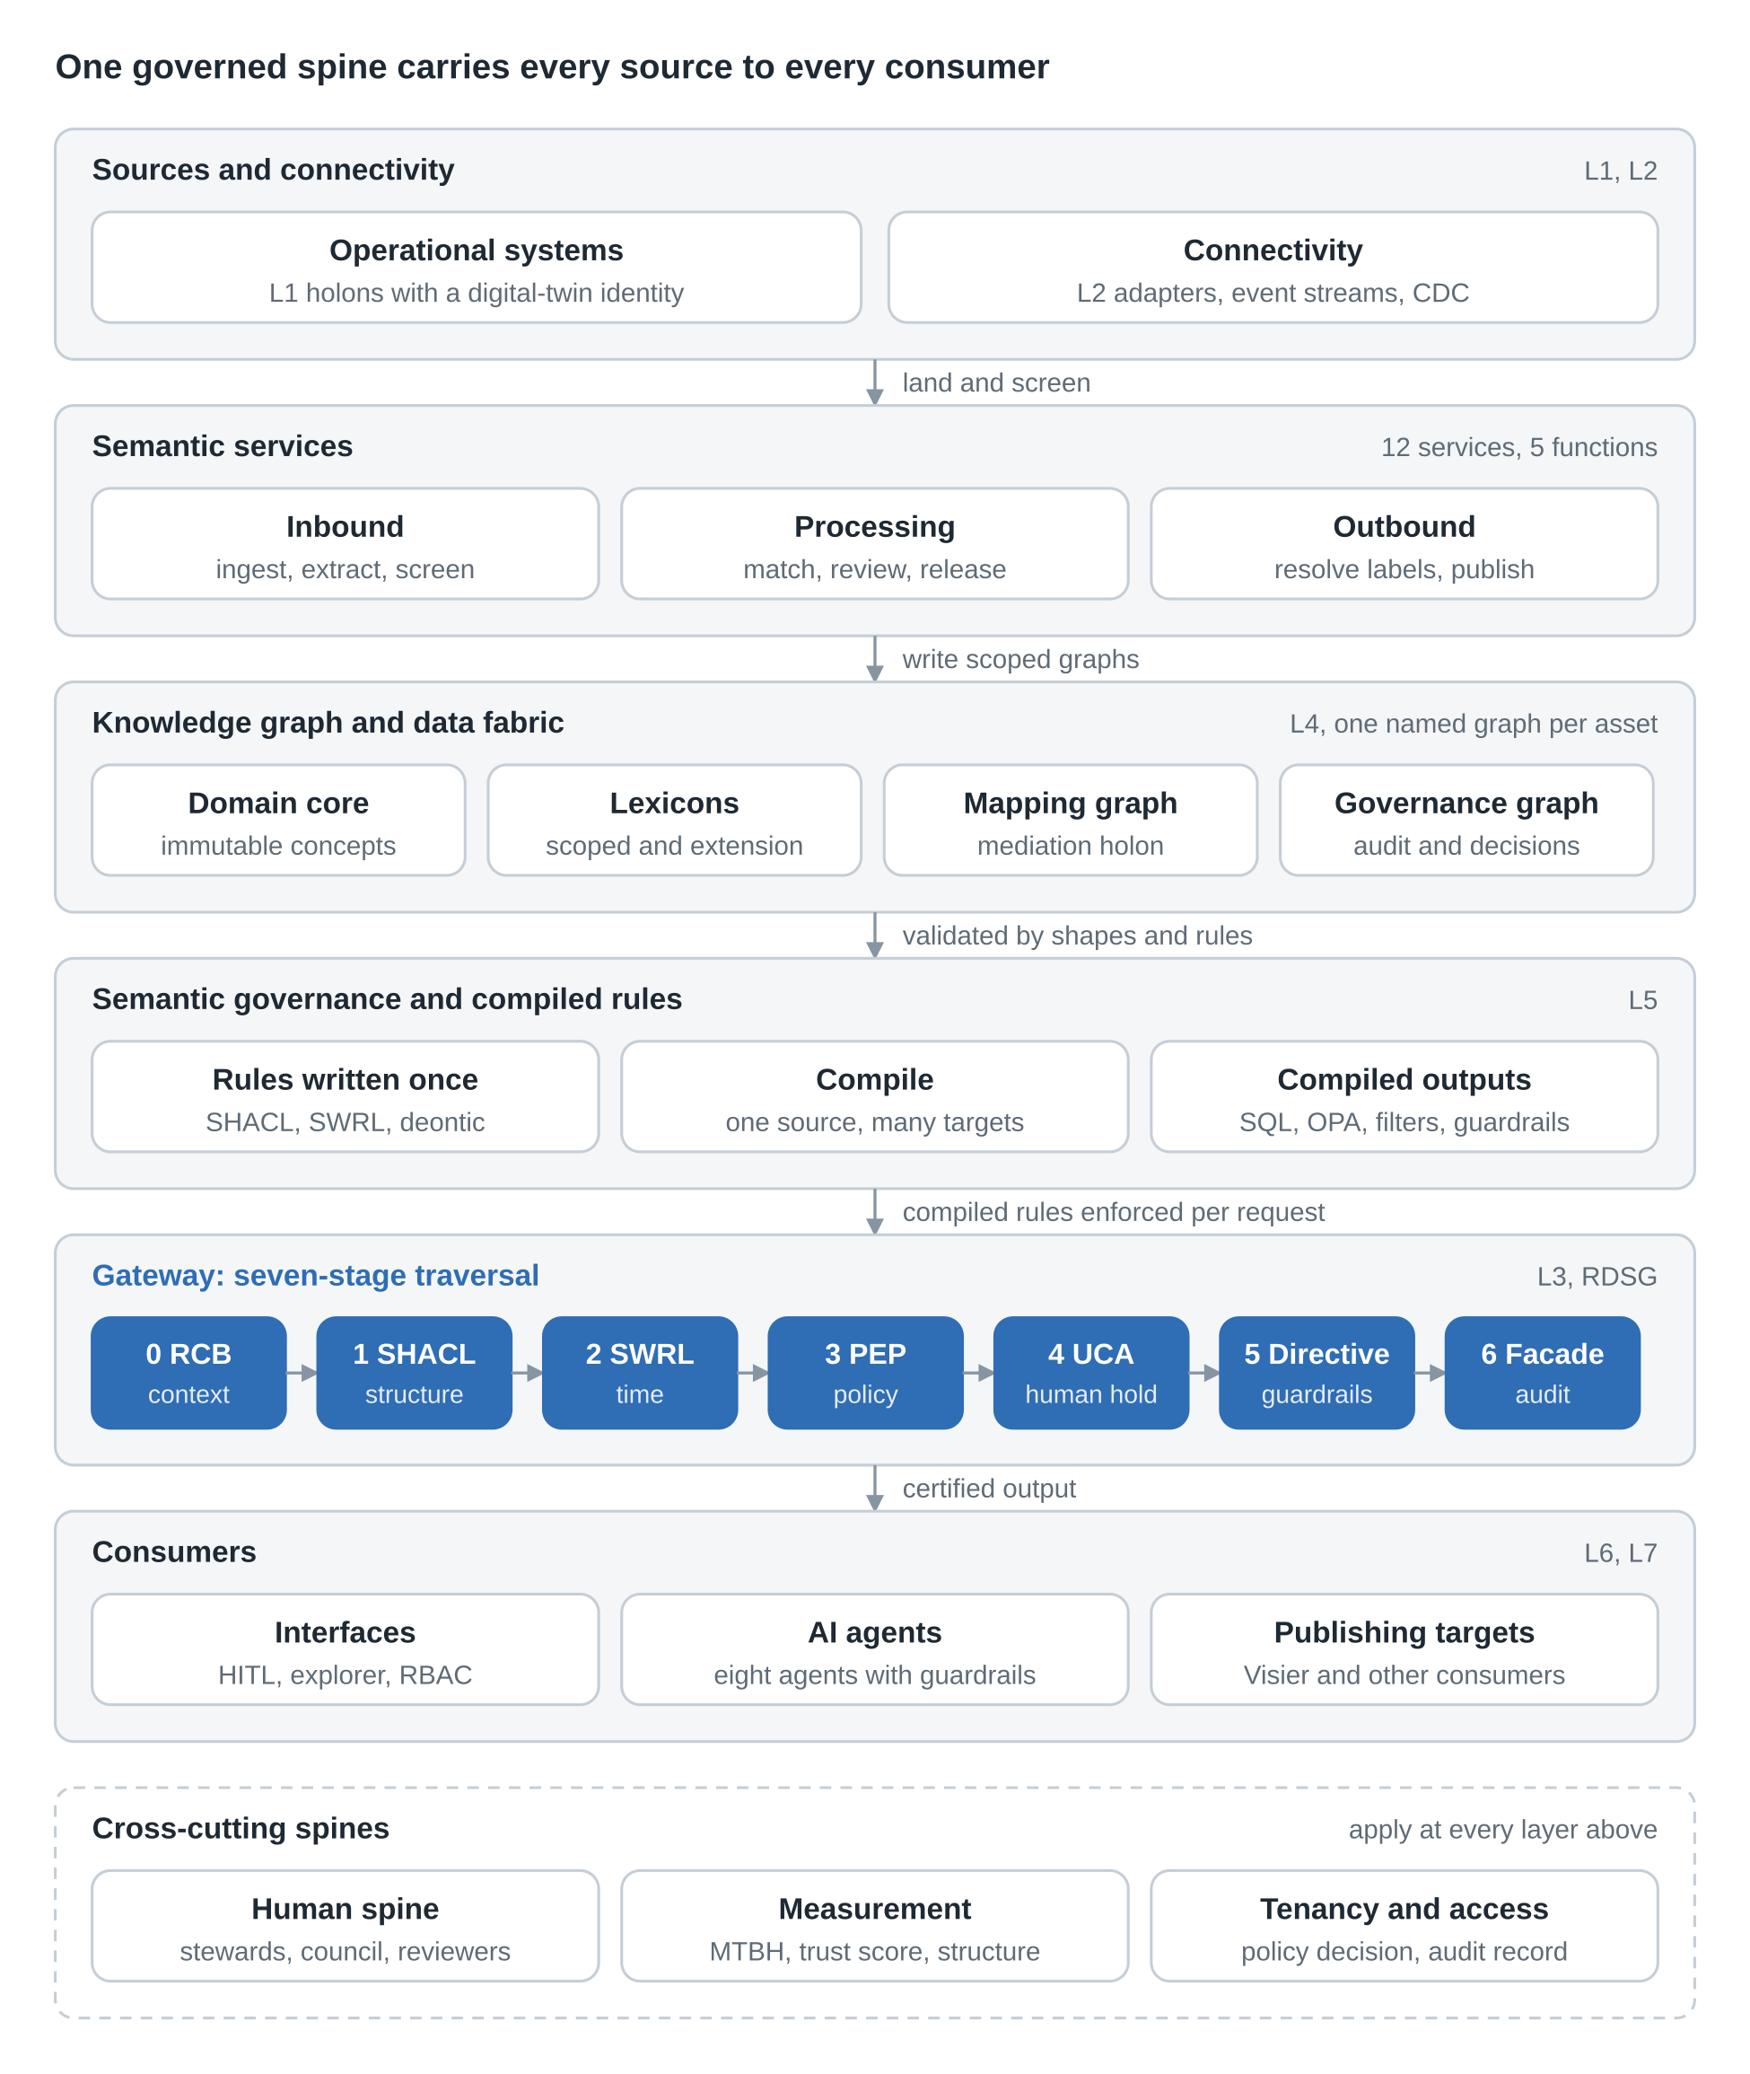
Figure 2. Complete architecture: 6 layers in the request path, 3 cross-cutting spines
Read the diagram top to bottom. Sources feed the semantic services, which write scoped graphs into the knowledge graph. Rules live once at L5 and compile to enforcement. The gateway is the single path every request and AI action takes, and only certified output reaches consumers. The human, measurement and tenancy spines apply at every layer. Sections 5 to 12 break each band down.

SECTION 5

Holonic structure
A holon is simultaneously a self-contained whole and a composable part; HSGA applies that to seven nested layers that are autonomous in their own scope and accountable to the layer above, following the Wymore system model M = (X, Y, W, S, Δ, λ, R).
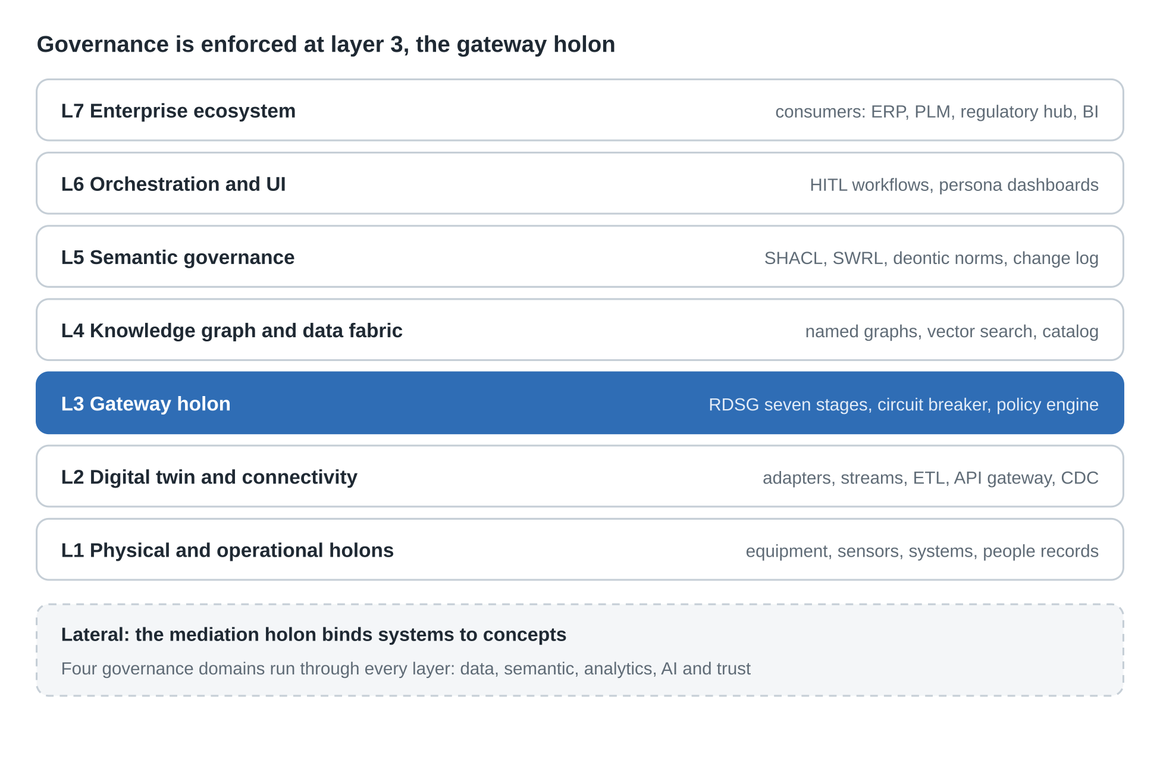
Figure 3. Seven-layer holarchy: 7 layers, 1 lateral holon
Layers 1 to 7 run from operations up to the enterprise ecosystem; the mediation holon is lateral, not an eighth layer.

5.1 Layers
Layer | What it holds | Wymore role
L7 Enterprise ecosystem | Consumers; every output traces to L4 and passes domain certification | Y output space
L6 Orchestration and UI | HITL workflows, intervention pane, SHACL viewer, ontology explorer, ontological RBAC | λ output function
L5 Semantic governance | SHACL library, SWRL temporal rules, deontic norms, ORSD-style contracts, KGCL change log | R performance specs
L4 Knowledge graph and data fabric | Triplestore with one named graph per asset (domain, lexicon, customer extension, governance), federated query, vector search, lakehouse, metric layer, catalog and lineage | W state space
L3 Gateway holon | RDSG traversal, trust circuit breaker, policy decision engine, safety specification, rule projection runtime | Δ transition function
L2 Digital twin and connectivity | Protocol adapters, twin registry, event streaming, ETL, API gateway, CDC; signals typed as RDF conformant with L5 | S admissible stimuli
L1 Physical and operational holons | Equipment, sensors, operational systems; each holon has a digital-twin identity with SHACL-governed state boundaries | X input space

5.2 Four governance domains
They run through every layer: data (catalog, lineage, quality gates, master data, access policy), semantic (ontology registry, SHACL, term lifecycle, external alignment), analytics (model registry, one governed definition per metric, certified dashboards), and AI and trust (trust scoring, circuit breaker, model cards, mandatory human gates).

5.3 Mediation holon
The mapping graph is a persistent lateral holon that insulates the top-down ontology from bottom-up implementations: RAG and vector stores, property graphs, dbt and LookML models, third-party ontologies and catalogs. It holds six correspondence types, scores each with confidence, and routes low-confidence mappings to a steward before promotion. It also separates the definition of governance rules from their runtime execution (section 11).

SECTION 6

Semantic design and naming standard
Every governed asset is one of five types at one of four tiers, and its name never carries a customer name, an environment, a version or a repository, so graphs can move without being renamed.

6.1 Design invariants
- Immutable core. Published core terms are never edited; deprecate with supersededBy and replace. Evolution is additive: add a parent, never reparent.
- Primitives are rare and rooted. Minted only at core or a top-level domain, with BFO lineage, kept minimal.
- Rooted acyclic derivation DAG. Multi-parent inheritance is allowed and limited; report any concept with more than two parents.
- Three edge types, default deny. Derivation, correspondence and lexicalization; an allowed-edge matrix by graph pair avoids a fully meshed graph.
- Core holds meaning; lexicons hold names. Core and domain terms keep preferred labels, definitions, relations and a small vetted set of universal alternate labels.
- Three orphan checks. Derivation path to BFO, schema binding coverage, label resolution; run per graph and per release, including each tenant graph.
- Five asset types, no modules. Vocabulary, taxonomy, ontology, lexicon, mapping. A lexicon holds labels only; a mapping holds match relations between assets.
- Four tiers with fixed content. Customer-tier assets are never ontologies; onboarding a customer adds no triples to a core or domain graph.
- Scope lives in the graph. One named graph per tenant; references point one way, from lexicon or extension up to core, by IRI.

6.2 Types by tier
Tier | Allowed types | Holds
Core | vocabulary, taxonomy, ontology, mapping | Preferred labels, definitions, relations, a small vetted set of universal alternate labels
Domain | vocabulary, taxonomy, ontology, lexicon, mapping | The same for one domain, plus labels common to that domain but not universal; operational domains follow this tier
Enterprise | vocabulary, taxonomy, lexicon, mapping | House terms valid for every tenant
Customer | vocabulary, taxonomy, lexicon, mapping | One tenant's labels and local concepts; never an ontology

6.3 Asset names
An asset name is lowercase ASCII words joined by hyphens: <type>-<tier>-<name>, or <type>-customer-<tenant-id>-<name>. A tenant ID is t plus 8 lowercase hex characters, opaque, issued at provisioning and never reused. The name part is proposed at 40 characters or fewer. A customer lexicon may omit the name part, as in lexicon-customer-t7f3a9c21.
Example (illustrative) | What it is
vocabulary-core-party | A core vocabulary
taxonomy-domain-workforce-advisory | A domain taxonomy
ontology-domain-payroll-operations | An operational-domain ontology
lexicon-enterprise-insperity | Insperity house terms
lexicon-customer-t7f3a9c21 | One tenant's labels
mapping-customer-t7f3a9c21-plan-names-to-benefit-classes | One tenant's match relations to domain concepts

6.4 Graph classes and IRIs
Every graph IRI derives from the asset URI, which is version-free and ends in the asset name. The path segments draft, sim, changes and catalog are reserved; a version segment always starts with a digit, so they cannot collide.
Graph class | IRI | Lifetime
Current release | Asset URI | Replaced by each release
Version | Asset URI + / + SemVer | Permanent
Draft | Asset URI + /draft/ + change ID | Deleted after release or rejection
Simulation | Asset URI + /sim/ + run ID | Deleted when the run record is closed; never writes to a current or version graph
Change records | Asset URI + /changes | Permanent, append-only
Catalog | Base URL + /catalog | Permanent

Repository IDs are environment-neutral: skl-core-domain, skl-lexicons, skl-extensions, and skl-tenant- plus the tenant ID for a dedicated repository. The environment belongs to the server address. Moving an asset between repositories changes only its catalog record.

6.5 Naming rules
# | Rule | Strength
1 | Lowercase ASCII letters, digits and hyphens; standard or customer form | MUST
2 | Type is one of the five; the word "module" is not used | MUST
3 | Core assets hold no customer-specific or enterprise-specific content | MUST NOT
4 | No customer name, environment, version, date, status or repository name in a name | MUST NOT
5 | A published name never changes; a rename is a new asset with the old one retired and its replacement recorded | MUST NOT
6 | Current-release IRI equals the asset URI; archived releases use version IRIs | MUST
7 | Tenant ID is opaque, issued once, never reused | MUST
8 | Services derive reachable graphs from caller tenant and persona; no graph IRI is accepted from a caller or screen | MUST
9 | A lexicon declares the assets it labels; labels point to concepts by IRI and never copy them | MUST
10 | A domain asset declares its parent core assets in metadata; parentage is not in the name | SHOULD
11 | Operational domains follow the domain tier; the first word of the name is the domain | MUST
12 | A draft graph is deleted when its change is released or rejected | MUST
13 | Prefixes are lowercase and unique across repositories; a customer-tier prefix begins with the tenant ID | MUST / SHOULD

The Metadata Standard changes in five places: term labels, asset types, new fields (tier, tenant ID, labelled assets, mapping source and target), the catalog record, and the glossary (add lexicon, mapping, tier, tenant ID, draft graph; codes L and M).

SECTION 7

Lexicon layer and customer terminology
Alternate labels and customer terms are held in scoped lexicons and customer extension vocabularies beside the core, so onboarding a customer adds no triples to the core, a label change never forces a core release, and one customer's terms never reach another.

7.1 Why labels do not live on the core
Putting every synonym on the core concept fails five ways: the core grows with every customer (growth); every label change needs a core release (churn); one customer's terms become visible to all (leakage); a flat list cannot say that the same word means different things to different customers (ambiguity); and a bare label records no source, approver or dates (lost evidence). Some terms are not synonyms at all and need a home that does not widen the core.
Option | Core size and speed | Tenant confidentiality | New customer meaning | Verdict
A. Labels on core concepts | Weak: grows with every customer | Weak: all tenants see all labels | Weak | Reject for customer labels; keep for a small vetted promoted set
B. Scoped lexicons | Strong: core unchanged | Strong: scope is the graph | Weak: names existing concepts only | Adopt for label-only terms
C. Customer extension vocabularies | Strong: core unchanged | Strong | Strong | Adopt for new local concepts
D. A copy of the core per customer | Weak: copies multiply | Strong | Partial | Reject: copies drift

B and C together, chosen by the triage rule, are the decision. B costs a resolution service and a derived index; C costs steward review of each match. Both are paid once per platform or once per concept.

7.2 Principles
- The core holds meaning, not vocabulary variety.
- A label is a record, not a property.
- Scope is enforced by where a label lives.
- References point one way, by ID; nothing is copied into the core.
- Machines propose, people decide.
- Derived is not source: the resolution index is rebuilt, never edited.
- Every change is traceable to source, evidence, reviewer, release and publish record.
- One contract per function, an adapter per source or target.
- No direct access to a graph; every read and write goes through a service or a provisioned screen.

7.3 The label record
A label is a resource modeled in the style of SKOS-XL, with PROV-O provenance and SHACL shapes validating each record.
Field | Holds
Label text and language | The literal form
Concept | ID of the core, domain or extension concept it names
Type | Alternate, hidden (match only, never shown), abbreviation, misspelling or deprecated
Scope and tenant | Customer, Insperity or domain; tenant ID for customer labels
Evidence | Source, document or page, span, frequency
Confidence and triage class | Machine score and proposed class
Status | Proposed, in review, approved, published, rejected or deprecated
Reviewer and time | Who decided, when and why
Effective dates and release | When it applies and the SKL release that carried it

7.4 Matching and match relations
Matching runs lexical first against preferred and approved labels after normalization, then embedding-assisted similarity with a confidence score. A customer concept links to the nearest core or domain concept by exactly one of four relations: exact, close, broad (core concept is wider) or narrow (core concept is more specific). A synonym, abbreviation or misspelling is never a match relation; it is a label. Match relations are re-checked on every core release.
Four cases are flagged and never resolved automatically: the same label points to different concepts in one scope; a label equals another concept's preferred label; the same label means different things in two tenants (both stay scoped, and reviewers see the pair as evidence); a candidate has no close match.

7.5 Triage
If the term is | It goes to | Approved by
The same meaning as an existing concept (synonym, abbreviation, plural, locale variant, misspelling) | A label record in the narrowest lexicon in which it is true | Ops reviewer
A homonym in this scope | Stays scoped, conflict flagged, disambiguation note | Domain steward
A new concept used by this customer only | The customer extension vocabulary, with a match relation | Domain steward
A new concept of general value, or a label seen across several customers or in regulation | A core or domain change request through the normal lifecycle | Governance council
Noise, out of scope, or personal data | Rejected with a reason; evidence kept | Ops reviewer

7.6 Label lifecycle, promotion and releases
A label starts Proposed, moves to In review, then Approved or Rejected. An approved label becomes Published only through a release; a published label can later be Deprecated. Every transition records who, when and why. A label that recurs across customers or appears in regulation can be promoted to a domain or core vocabulary as a universal alternate label by council decision and ships in a core release; a promoted label that later conflicts is demoted the same way. Lexicon changes release on their own cadence per scope; a lexicon release never changes the core version.

7.7 Resolution
Callers pass text and a tenant context. The label resolution service looks first in that customer's lexicon, then the Insperity lexicon, then the domain lexicon, then core preferred labels. It never searches another tenant's graphs, matches hidden labels without displaying them, and returns candidates with definitions when several concepts match at the same level. It answers from a derived index rebuilt on each release, not from the ontology graphs.
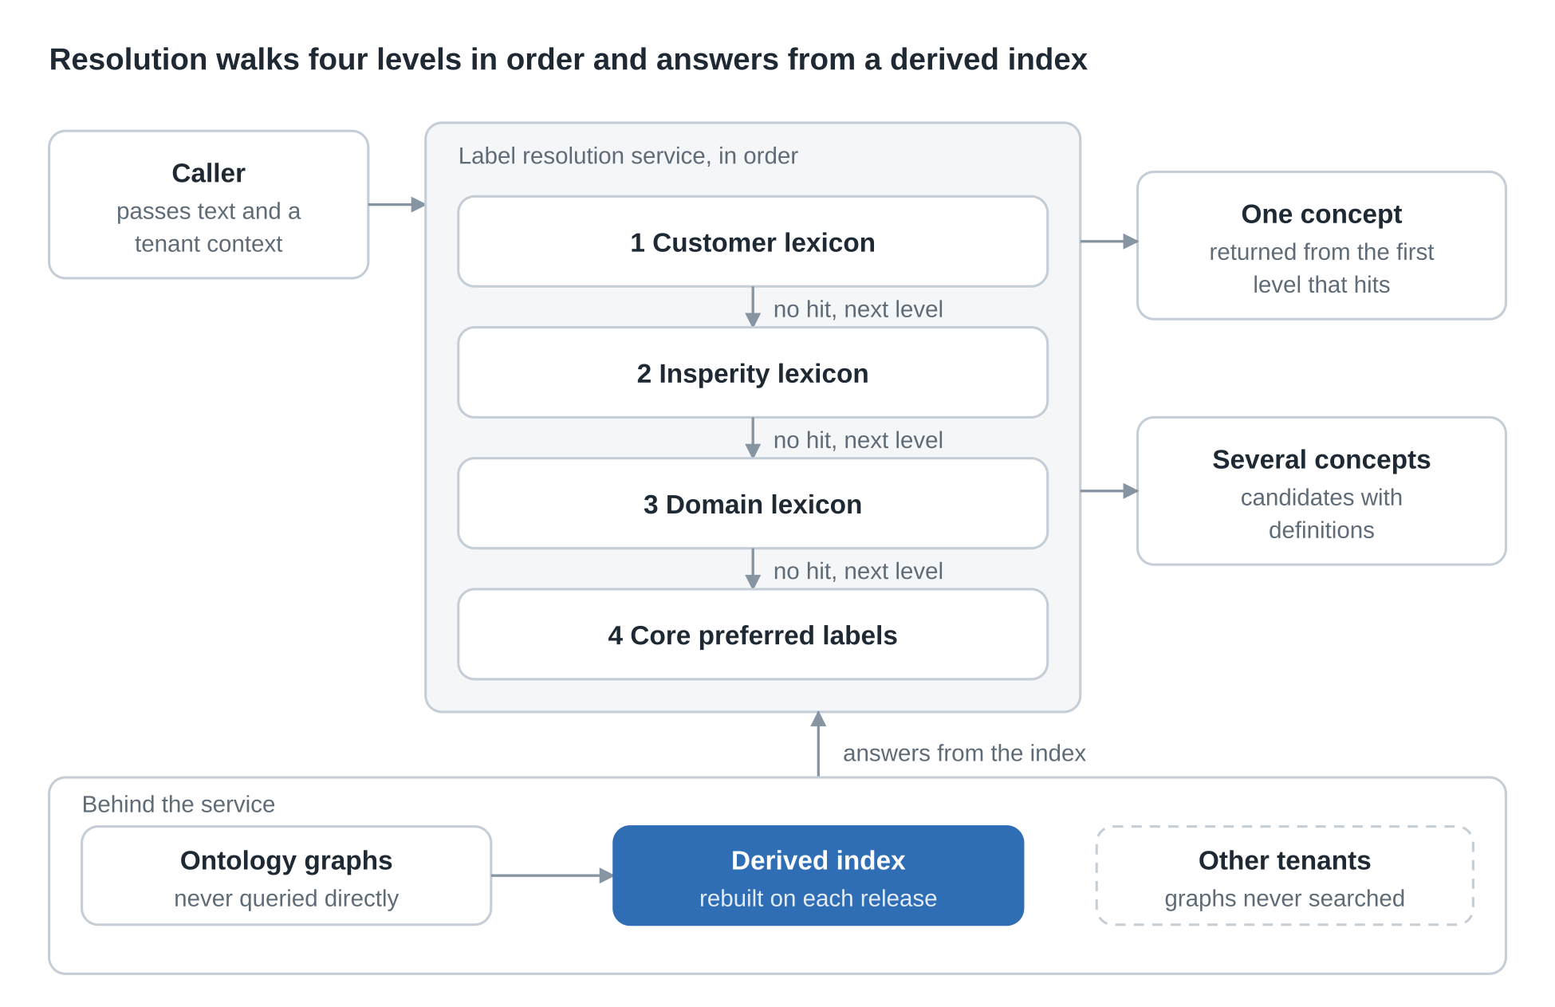
Figure 4. Label resolution: 4 levels, 1 derived index
The service stops at the first level that hits. The dashed box is outside its reach by design.

SECTION 8

Tenancy, personas and access
Each customer has its own named graphs, no repository is ever exposed, and what a person may do is decided from persona, job step, resource and context rather than a permission list.

8.1 Repositories and topology
Assuming GraphDB, one server per environment (dev, test, stage, prod) hosts a few repositories, split by reasoning and release cadence, not by tenant.
Repository | Holds | Reasoning | Why separate
skl-core-domain | Core, domain and operational-domain vocabularies, taxonomies, ontologies and mapping graphs, one named graph per asset | On | Released and reasoned together
skl-lexicons | Insperity lexicon and one named graph per tenant lexicon | Off or minimal | Labels stay out of reasoning and core releases
skl-extensions | Local concepts and match relations, one named graph per tenant | Light | Own release and deletion per tenant

The raw landing zone, candidate store and resolution index need not live in GraphDB. The core and domain repository is the same in every stage of growth; growth happens in the lexicon and extension repositories. Only where a customer contract or blast radius requires does a tenant move to a dedicated repository or server (skl-tenant- plus the tenant ID), and the move changes only its catalog record.

8.2 Isolation and privacy
- No direct access. No repository is exposed to people, other systems or third parties. The store workbench and admin accounts are closed to normal use; break-glass access is time-bound and logged.
- Tenant tag from the first byte. Every item carries a tenant ID from landing, and every query a tenant context.
- Isolation enforced by services. Each tenant lexicon and extension vocabulary is its own named graph; services build the graph restriction into every query, accept no raw queries, and use separate read and write accounts. Store-level graph controls are a second layer.
- No cross-tenant path. The one exception is promotion counting: reviewers see a count, never another tenant's evidence.
- Fail-closed screening. Personal and sensitive content is detected, redacted or quarantined before extraction; a red-team set tests it before the pilot gate.
- Audit and exit. Every read and write is logged. Offboarding removes the landing zone, graphs and index entries with no change to the core.

Written permission to use each customer's documents and feeds, a retention rule and data-use terms are conditions of onboarding.

8.3 Operational personas (proposed)
The persona and job catalog is owned by Personas & Jobs, which will supply fine-grained identity and access controls beyond traditional ACLs.
Persona | Jobs | Works on
Tenant provisioner | Create, suspend, remove a tenant; rotate service credentials | Tenant records and graphs, never content
Onboarding lead | Register sources, confirm data permission, run onboarding | One tenant's sources and ingest reports
Ops reviewer | Decide candidates, edit labels, raise escalations | Candidates and labels for assigned tenants
Domain steward | Approve match relations and local concepts; maintain vocabularies, taxonomies, mappings | Assets in the domains they steward
Ontologist | Propose changes to ontologies, triage rules, naming | Ontology assets, through the lifecycle
Platform operator | Run pipelines, releases, rollback, drift response | Services and releases, never content
Council member | Approve releases, label promotion, cross-domain conflicts | Release and promotion decisions
Auditor | Read the audit trail and decision records | Records only

8.4 How access is decided
Each request carries the person's persona assignments; the job and job step being performed; the resource (graph class, tenant, domain, item state); and the context (assignment, time). The service decides from rules authored in the SKL as governed rules, and logs the decision with the persona, job and step that authorized it. Rules a permission list cannot express:
- A reviewer decides only items assigned to them, in tenants they are provisioned for, while the item is In review.
- Nobody approves their own change; the proposing persona cannot be the approving one.
- The approval power of a steward ends at the domains they steward.
- A person with two personas has each persona's rights only while doing that persona's jobs.
- Elevated access is time-bound, logged and reviewed.

8.5 Provisioning
Provisioning is a persona job through the same screens and audit. Tenant: register; create lexicon and extension graphs, indexes and review queue; bind policies and persona assignments; confirm written data permission; activate. Deprovisioning reverses each step. Person: assign personas with tenant and domain scope and an end date; complete training and calibration; activate. Assignments are reassessed periodically and revoked at once for movers and leavers.

SECTION 9

Semantic services and operations extensions
Five functions (capture, warehouse, map, manage, serve) are delivered by twelve semantic services; every graph is reached only through them, and screens, dashboards and later projects are built on their contracts.

9.1 The services
Group | Service | Responsibility
Inbound | Ingestion | Lands each item with tenant tag, provenance and change capture, one connector per source type
Inbound | Extraction | Recovers text, structure and language; OCR for scans
Inbound | Screening | Detects personal and sensitive content before any other step; fails closed
Processing | Candidates | Extracts terms, defined terms and drafted definitions with evidence; normalizes and merges variants
Processing | Matching and triage | Matches candidates to concepts, proposes match relations, classifies each as label, local concept, core request or rejection
Processing | Lexicon | Writes label records and extension vocabularies to scoped graphs; validates shapes; detects conflicts
Processing | Review | Lifecycle state machine, assignments, decisions, audit trail
Processing | Release | Validation, versioned releases, promotion and rollback across environments; records changes as triples
Outbound | Label resolution | Tenant-scoped lookups from the derived index
Outbound | Publishing | Projects, validates, delivers and reconciles releases to targets through adapters
Common | Policy decision | Decides each request from persona, job step, resource and context
Common | Telemetry | Receives events from every service for monitoring, triage and simulation

Every service shares five rules: each request carries caller identity and tenant context; a policy decision is logged before any read or write; graph access is parameterized and no service accepts a raw query; each service emits events for request, decision, outcome and duration; the contract is versioned and changing it is a governed change.
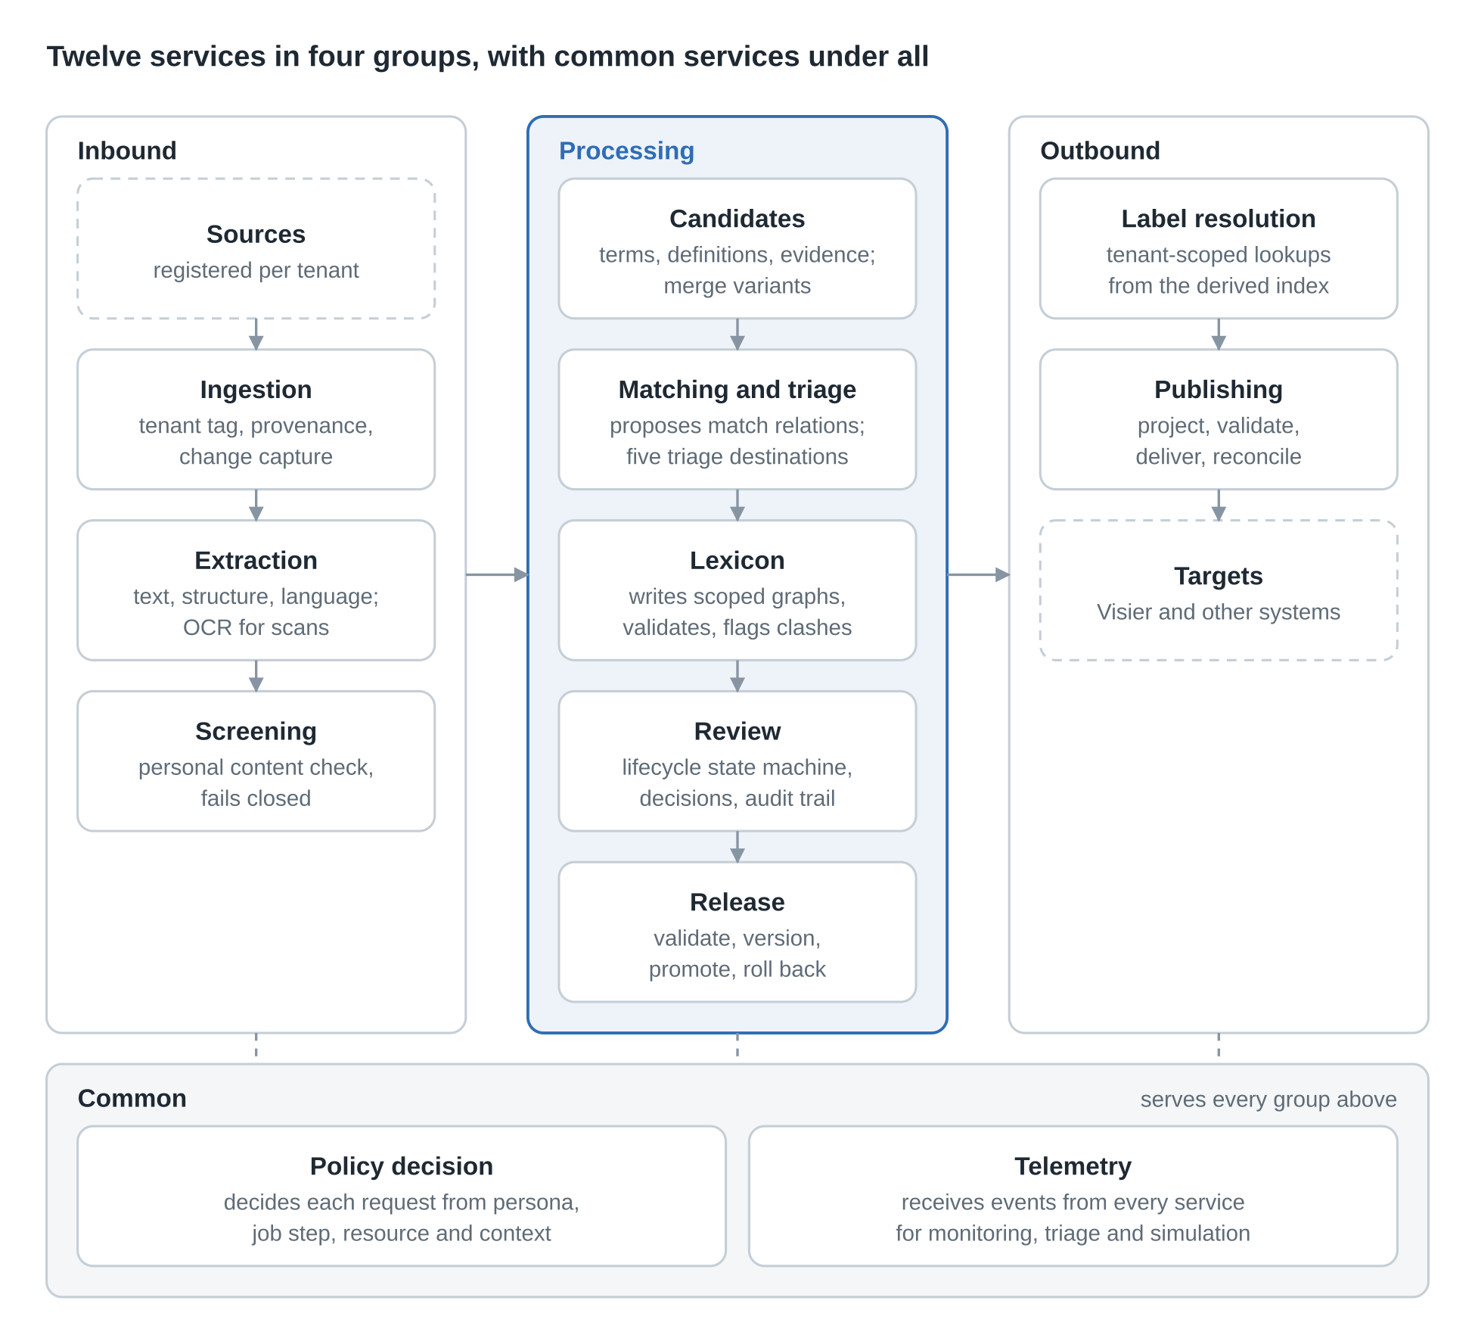
Figure 5. Semantic services: 12 services in 4 groups
Items move left to right: inbound services land and screen, processing services turn candidates into released vocabulary, and outbound services serve and publish it. The two common services sit under every group.

9.2 Capture and warehouse
Four source types are in scope: customer documentation (upload or file share), the content management system (API or export, incremental), customer data feeds (file, SFTP or API with declarative R2RML-style mappings) and employee handbooks (section-aware parsing, OCR). Each passes five steps: land (tenant tag, source, version, hash), screen (fails closed; unclear items quarantined), extract, propose (a definition is drafted only when a source span supports it), normalize. Only the candidate record, with text, evidence span, source, tenant, frequency and confidence, leaves capture.
The warehouse keeps each store separate: raw landing (per tenant, never loaded into a graph), candidate store (working data, never released), core and domain graphs (versioned releases), Insperity lexicon, customer lexicons and customer extensions (own version per tenant), resolution index (disposable, rebuilt on release), and change records (append-only triples).

9.3 Publishing to targets
Publishing follows the SKL contract: publish, validate, reconcile, status and rollback, one adapter per target. For Visier, released vocabularies and taxonomies publish as dimension members and property values, each stamped with its SKL ID and version; synonyms and definitions stay in the SKL. Visier consumes and never edits; any difference on read-back is drift, corrected in the SKL.
Two points are not settled. The display-label rule (each member shows the tenant's approved label where one exists, otherwise the preferred label) is proposed for confirmation. Whether Visier can hold a tenant-specific name for a published member is unconfirmed; task W6-01 asks Visier, and if the answer is no the preferred label is published and customer terms resolve in Copilot, Compass and search. Visier limits come from public documentation and should be checked against the tenant.

9.4 Operations extensions
These are built on the service contracts, add no route to a graph, and can change without changing the baseline.
Extension | What it adds | Calls | Used by
Review and maintenance screens | Governed data entry for labels, local concepts, vocabularies, taxonomies, ontologies, mappings | Review, Lexicon, Release, Policy decision | Ops reviewers, stewards, ontologists
Provisioning | Tenant and person lifecycles, persona assignment, recertification | Policy decision, Lexicon, Telemetry | Tenant provisioner, onboarding lead
Monitoring dashboards | Pipeline, processing quality, review work, service health, access and security, releases, capacity | Telemetry | Platform operators, ops review lead, auditors, council
Triage | One queue of alerts and exceptions with severity, owner and runbook | Telemetry, Review | Platform operators, ops review lead
Simulation | What-if runs showing the impact of a change before it is made | Release, Matching, Publishing, Telemetry | Stewards, ontologists, council, program manager

The review screens are the candidate queue, evidence viewer, concept picker, alternate-label editor, conflict panel, local-concept creator, lexicon browser, escalation and promotion inbox, and reviewer dashboard. Dashboards read telemetry, never the graphs. Operational triage (failed ingests, quarantines, drift, parity failures, repeated denials, expiring assignments, service-level breaches) is separate from candidate triage in Manage.
Simulation loads a proposed change into a draft graph and compares it with the current release without publishing. Workspaces use the reserved sim segment. The impact view shows concepts, labels, mappings and tenants affected, the objects that would change in each target, new conflicts, reviewer workload, and for capacity runs the predicted load, reasoning and lookup time. Candidate simulations: a core or domain release, label promotion or demotion, a changed match relation, an access rule, a new tenant or volume growth, and a Visier projection as a dry run.

SECTION 10

Logic single source of truth
Business logic is defined once in a declarative spec under version control, compiled into what each runtime needs, and reached through one Decision API, so rules cannot drift between code, rules engines and ontologies.
The problem has three compounding forms: duplication (the same eligibility rule in a stored procedure, a Drools ruleset and a service-layer condition), silent drift (an incident fix applied in one place only) and no audit trail (rules edited directly in production with no review). Forcing everything into one tool fails, because procedural algorithms do not belong in a rules engine and stateful workflows do not belong in an ontology.

10.1 Right home by layer
Category | Question it answers | Home | Example
Constraints | What must always be true about the domain data? | Ontologies (OWL/RDF), schemas (JSON Schema, OpenAPI, Pydantic, Protobuf) | An order has at least one line item and the customer exists
Business rules | What actions or decisions follow from state? | Rules engines (Drools, Camunda, DMN) or a DSL | Gold tier and order over $100 gets 15% off
Computation | How is state computed or processed in sequence? | Code: microservices, DDD domain services | Route optimization, a multi-step feature pipeline

10.2 Governance pipeline
Specs live in a central repository in human-readable form (YAML, DMN, Turtle/OWL). Nobody edits a rule in a rules-engine screen or a production database; everything is committed first and reaches production only through CI. CI runs semantic reasoners (for example HermiT) for contradictory axioms and static analysis for malformed or conflicting DMN tables, then scenario tests against synthetic datasets. Rule sets and schemas carry semantic versions, and each consuming service declares the version it depends on, so a change cannot silently break a consumer. Rejected changes return to the author.

10.3 Generated executables and the Decision API
On every merge, code generators produce TypeScript and Python interfaces for microservices, SHACL/OWL files for the graph store, and DMN/Drools XML for the rules engine, all from the same spec. Drift becomes a build failure, not a production incident.
At run time callers do not reach the rules engine, ontology store or a legacy procedure directly. They call the Decision API, which resolves the caller's declared policy version, validates the request against the current schema, and routes to whichever backend owns the decision, including a wrapped legacy engine not yet migrated.
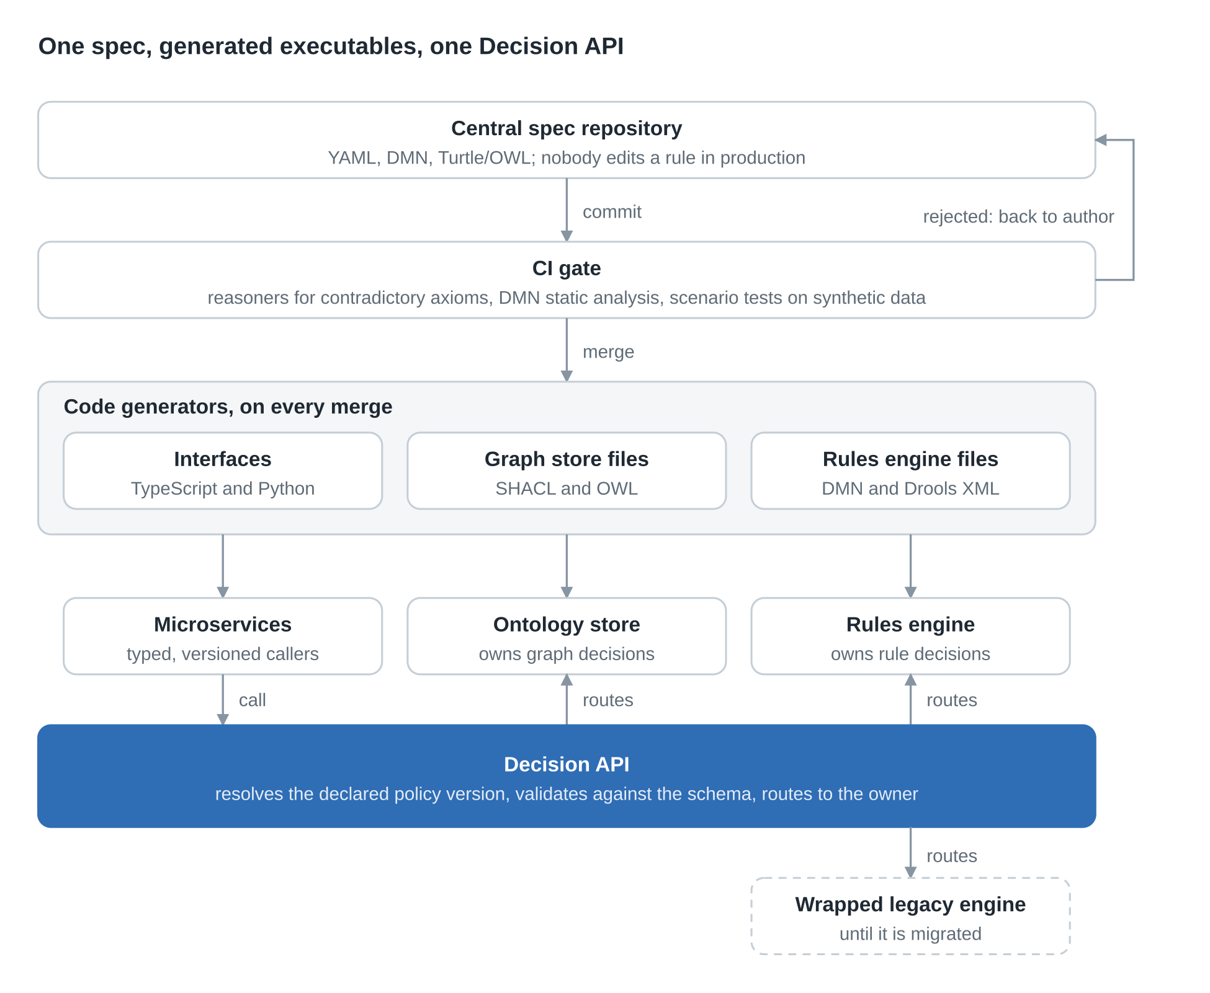
Figure 6. Logic single source of truth: spec to Decision API
Only the spec repository is edited by people. Everything below it is generated or routed, and the dashed box is the legacy engine that the strangler-fig migration retires.

10.4 Migration
- Discover and classify. Inventory and audit with tracing and static analysis; log every point where a business decision is made; sort each into constraint, rule or computation.
- Decouple behind the API (strangler fig). Wrap legacy engines and stored procedures behind the Decision API before touching internals; extract hardcoded logic into configuration or DMN piece by piece, re-pointing the facade as each piece lands.
- Schemas first, rules second. Unify data definitions through a common ontology or schema registry, then consolidate rules; many apparent rule conflicts are data-shape conflicts.

Start with the repository and CI pipeline before extracting any rule; pilot on one bounded decision such as discount eligibility; run Phase 1 broadly before committing to Phase 2; make version declaration mandatory from day one.

10.5 Relation to compiled governance
The same write-once, compile-per-runtime pattern appears in section 11 for semantic governance rules. Treating the two as one pipeline is a proposed alignment, not a statement in either source document.

SECTION 11

Runtime governance
Every request and AI action takes the same seven-stage path through the gateway, rules are compiled once to where they are enforced, and agents do the continuous watching while people hold the decisions that carry judgment or risk.

11.1 Gateway stages (RDSG)
Stage | Name | What it does | Human part
0 | RCB | Assembles the Requirement Context Bundle: who, what, when, where, why; activates domain holons
1 | SHACL | Checks structure; 212+ shapes; critical violations halt and route to the Domain Governance Team
2 | SWRL | Checks validity in time with 96+ temporal rules, so expired constraints are never applied
3 | PEP | Checks the four governance domains permit it for this person and purpose; cross-jurisdiction conflicts go to the Enterprise Governance Council | Yes
4 | UCA | Holds unsafe or irreversible actions at the Simplex Action Gateway for human authorization | Yes
5 | Directive | Issues a compiled AI Directive carrying guardrails
6 | Facade | Checks acceptance criteria, applies the five-dimension trust score, commits the audit record to the Governance Named Graph, quarantines tripped outputs | Yes

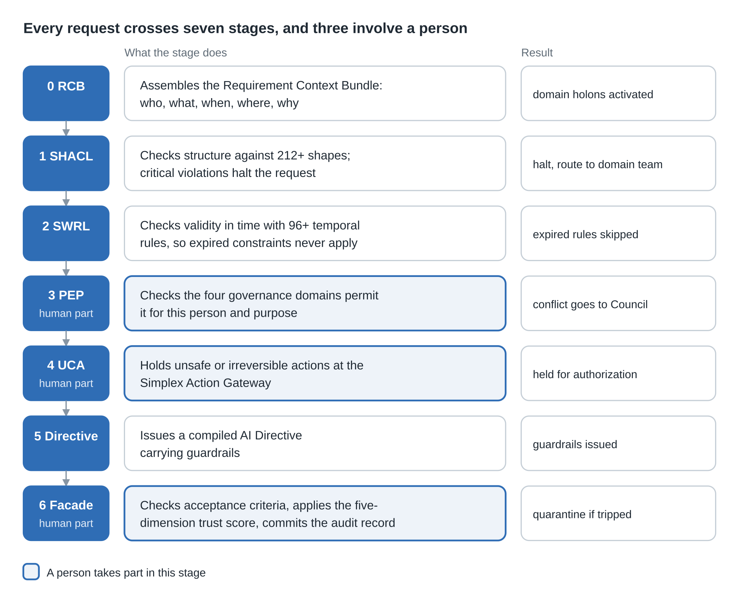
Figure 7. Gateway traversal: 7 stages, 3 with a human part
Stages run in order. A critical failure at stage 1 stops the request, and the three highlighted stages need a person.

11.2 Compiled governance
Rules are authored once as SHACL shapes, SWRL rules and LKIF-style deontic norms (obligation, permission, prohibition), harmonized by the Rule Harmonization Engine into one conflict-checked contract. The Rule Projection Agent compiles them to runtime targets (SQL CHECK constraints and dbt tests, OPA policies, vector-store filters, agent guardrails), versions each artifact with a KGCL record, and keeps a compiled policy registry and cache so the graph reasoner stays off the request path. Roles come from ontological definitions, not hand-edited permission lists.

11.3 Agents and loop
Eight agents operate: lineage ingestion, mapping confidence, rule projection, ontology alignment (HITL-gated), drift detection, RAG grounding, compliance monitoring (HITL-gated) and recursive learning (HITL-gated). The loop is Observe, Reason, Propose, HITL review, Adapt. Agents never write governed graphs directly.

11.4 Human checkpoints
Checkpoint | Decided by
Ontology change | Domain Architect with the Council
Weak mapping below threshold | Knowledge or Data Steward
Rule conflict across jurisdictions | Enterprise Governance Council
Irreversible action | Safety Reviewer
Low-trust output (quarantined) | Domain Governance Team
Candidate term (label or reject) | Ops reviewer
Match relation or local concept | Domain steward
Label promotion, core request, cross-domain conflict | Governance council

In the lexicon layer, extraction and matching propose and reviewers decide: the same rule that governs the eight agents. Persona names are illustrative; role definitions, not individuals, carry authority.

SECTION 12

Measurement and assurance
Trust is measured, not assumed: MTBH gates AI actions, structural measures show whether the semantic design stays disciplined, and lexicon-layer targets prove the core stays small and tenants stay isolated.

12.1 MTBH
Mean Time Between Hallucinations is total operational time divided by verified hallucinations or breaker trips: MTBH = T_ops / N_h, as defined in the metrics registry of the AI Circuit Breaker v3.0 design. Track it under statistical process control; a falling MTBH is an early warning that the system is outside its validated envelope. The baseline uses 32 measures, a 150-question gold set baselined at Gate 1, and SPC monitoring on MTBH.

12.2 Structural measures
Dashboards read telemetry only, so each measure is emitted as a telemetry event by the check that computes it.
Measure | What it shows
Correspondence density | Lateral links per concept; too dense drifts toward a meshed graph, too sparse means fragmentation
Stem-reuse ratio | Share of new terms built from existing stems
Impact radius | Terms affected by a core change, before approval
Polyhierarchy rate | Concepts with more than one parent; reported above two
Domain-minted primitive share | Primitives minted outside core; should stay minimal
Promotion-backlog age | How long pending terms wait; long waits mean HITL capacity is the bottleneck
HITL disposition mix | Label, domain concept, core change, reject; a shifting mix suggests gaps
Orphan rate per graph | Local concepts with no derivation path; target 0, checked in every tenant graph

12.3 Lexicon-layer targets
The claims are unproven until measured. Spike W2-02 builds a synthetic core and holds the same labels two ways, in the core and in scoped lexicons, measuring load, reasoning and query time, index size and release size at rising label and tenant volumes. Pass thresholds are agreed first (W1-04) so the result cannot move them; scale test W7-03 repeats it on the built system. Customer counts and labels per customer are not yet known, so the decision record states the synthetic parameters.
Measure | Target | Tested in
Customer-driven triples added to the core per onboarding | 0 | Lexicon builder; second-customer onboarding
Core load and reasoning time at top test volume | Within a tolerance set before the spike | W2-02, W7-03
P95 label lookup time | Threshold set from the spike | W2-02; Label Resolution Service
Cross-tenant label results | 0 | Isolation tests
Core releases triggered by a label change | None | Release pipeline
Label records with source, reviewer and release | 100% | Review service

Also reported per customer and per release: lead time from first source to approved lexicon; candidates decided per reviewer-hour and age of the oldest open item; precision and recall of extraction, matching and triage on the gold set with reviewer agreement; drift incidents per release and parity failures caught before publish. Review service levels are set from the pilot, not guessed.

12.4 Lifecycle fit
HSGA governs the information baseline across the systems-engineering V-model, from stakeholder needs through operations, so requirements, architecture and design items are machine-checked early and monitored after fielding. Mapped from ISO/IEC 15288, the INCOSE SE Handbook and DoD AAF; artifact IDs are in v4.2.

SECTION 13

Roadmap, decisions and risks
Delivery is phased and gated by measured evidence; three lexicon-layer decisions await council approval and the register below holds everything else open.

13.1 Programme phases
Phase | Focus | Exit evidence
1. Seed and baseline | Seed core from standards, 50+ shapes, charter the council, set trust baselines, stand up model registry | Gate 1 baseline: 150-question gold set; structural measures emitting telemetry
2. Extend and certify | Cross-domain extensions, 200+ shapes, external alignments, certification, ontology-driven access | Per-tenant graphs onboarded; 100% HITL compliance
3. Scale and self-serve | SHACL compliance above 99%, self-service extension toolkit, full deontic library, continuous trust monitoring | Anti-collapse protocol validated

13.2 Semantic services pilot and gates
The pilot uses one customer, one instance of each of the four source types, the downturn workforce advisory vocabularies from the SKL proposal, and Visier as first target. Planning dates assume a 9 November 2026 start and a pause from 21 December to 3 January.
Gate | Planning date | What is true when it passes
G0 | 21 Dec 2026 | Label architecture decided on benchmark evidence; council seated; naming, ID and multi-parent rules agreed; inbound, processing and publishing contracts published; pilot customer, stewards and data permission confirmed
G1 | 8 Mar 2027 | All four source types ingested with provenance on every record; no personal-data leaks in the red team; candidates triaged into scoped lexicons; zero customer-driven triples in the core; zero cross-tenant results
G2 | 3 May 2027 | Pilot vocabularies live in Visier in one version with parity and reconcile checks clean; pilot customer lexicon reviewed by operations and published for its tenant
G3 | 24 May 2027 | Scale test passed; second customer onboarded from the playbook with no change to the core; second target live; runbooks drilled

13.3 Decision register
Change the status with the dropdown and record the version in which it changed.
ID | Decision | Status | Note
D1 | Primitives need BFO lineage, minimal, top-level domains only | Decided | Reflected in invariants
D2 | Labels and tenant concepts live in separate graphs, never in core or domain ontologies | Decided | Refined by the lexicon layer
D3 | MTBH is defined by the AI Circuit Breaker v3.0 metrics registry | Decided
D4 | Nested-domain primitive minting: do area containers count as top level? | Open
D5 | Persona search ranking wording must match graph-scoped resolution | Open
D6 | Simulation sequencing against the roadmap, and which simulation is built first | Open | Label promotion, core release, Visier projection or capacity planning
D7 | Council approver role, and who approves a customer term that maps to nothing in the core | Open | Listed open in one section, defined in the roles table
D8 | Monitoring pattern: dashboards read telemetry only, but the guide reads model files | Open
D9 | Adopt the lexicon-layer pattern (scoped lexicons, extension vocabularies, derived index) | Proposed | Decision requested
D10 | Adopt the five-function service model as baseline for every customer | Proposed | Decision requested
D11 | Run benchmark spike W2-02 before build, thresholds set first in W1-04 | Proposed | Decision requested
D12 | Tenant ID format (t plus 8 hex) and name length limit (40 proposed) | Open
D13 | Persona-specific labels: stay on terms when true for every tenant, move to a lexicon otherwise? | Open
D14 | May an ontology exist at the enterprise tier? | Open
D15 | One catalog graph, or one per repository? | Open
D16 | URI path pattern for lexicon and mapping assets | Open

13.4 Risks and mitigations
Risk | Mitigation
Lexicon layer adds a run-time lookup the core did not need | Derived index; P95 threshold set before the spike; spike and scale test
Extraction floods reviewers with low-value candidates | Confidence floors, de-duplication, gold set, triage precision target, bulk actions
Reviewers approve a label at the wrong scope | Narrowest scope default; conflict panel; steward escalation; promotion only through the council
Extension concepts drift from the core | Re-check match relations on every core release; drift report
Customer documents hold personal or confidential content | Written permission; fail-closed screening; retention rule; red-team test
Visier cannot hold tenant-specific names, or its Dimensions API (Alpha) is not ready | Ask early (W6-01); publish preferred label; file-based or Direct Data Intake fallback; labels stay in the SKL
Volumes unknown, so the spike is unrepresentative | Record synthetic parameters; repeat at scale test and final gate with real counts
Labels go stale | Effective dates, deprecation, periodic review of unused labels
Service-layer authorization flaw exposes one tenant to another | Parameterized queries only, separate read and write accounts, isolation tests in the pipeline, store graph controls as backstop
Store admin or workbench access bypasses the services | Private network, workbench closed, time-bound logged break-glass, encrypted backups
Persona and job rules too coarse or tangled to maintain | Author as governed rules with test cases; review with Personas & Jobs; pilot on reviewer and steward personas

13.5 Open questions
- Which customer is the pilot, and which CMS and feed formats does it use?
- Which graph store, review-application host and CI platform will the baseline use?
- How many customers and labels per customer should the spike and scale test assume?
- Who staffs operations review, and how many hours a week?
- Which languages beyond English appear in the pilot sources?
- What are the pass thresholds for core load, reasoning time and lookup time?
- Which identity provider and policy engine make access decisions, and where are persona and job assignments held?
- Who owns the persona and job catalog, and how are changes released?
- What is the break-glass procedure for store admin access, and who approves it?
- Which telemetry platform holds service events and audit records, and for how long?

SECTION 14

Maintenance guide
Every change follows the same five steps, and its size decides the version number. This process is proposed; adjust it when the council sets its own.

14.1 Change classes
Class | Examples | Version effect
Major | Change an invariant; add or remove an asset type or tier; change a MUST rule; change the service contract model | New MAJOR, status resets to Draft
Minor | Add a service, persona, measure or section; settle an open decision without breaking an invariant | New MINOR
Revision | Wording, corrections, new examples | Note in the version history, no new number

14.2 Amendment steps
- Describe the change and its class in a comment on the section it touches.
- Edit the section. Keep numbering stable; add new subsections at the end of a section.
- Add a row at the top of the version history: version, date, class, what changed, sources. Do not alter older rows.
- Update the decision register: new decisions as Proposed or Open, settled ones as Decided with the version in the Note column.
- Move the status in Document control to In review. Only the council sets Approved.

14.3 Keep in step
- The HSGA Explorer walkthrough, which mirrors sections 4 to 13.
- The graph naming standard and the Semantic Asset Metadata Standard, when a naming rule or asset type changes.
- The Semantic Services Baseline plan, when a gate date or service contract changes.

14.4 Conventions
- Example names, tenant IDs and customer terms are illustrative; label them so.
- A published asset name never changes; document a rename as a new asset and a retirement.
- Record facts from source documents with the source in the version history. Mark anything inferred as proposed.
- Use the document history to compare or restore earlier text instead of retyping it.

SECTION 15

Sources and related documents
Version 5.0 draws only on these four documents; none is a web source.
Document | Date | Used for
Holonic Semantic Governance Architecture, v4.2, Reference Topology and Governance Diagram Edition | not recorded | Holonic theory, seven-layer holarchy, gateway, compiled governance, agents, measurement, lifecycle fit, standards foundation
Architecture Proposal: Alternate Labels and Customer Terminology | 31 Oct 2026 | Lexicon layer, services, tenancy, personas, access, operations extensions, pilot gates, risks
Graph Naming Standard: Insert for Semantic Governance Standards | 1 Nov 2026 | Asset types and tiers, names, graph classes, repository and tenant IDs, rules, amendments
Untangling Scattered Business Logic: an SSOT Architecture | not recorded | Logic classification, governance pipeline, generated executables, Decision API, migration

The lexicon proposal in turn cites the SKL proposal "SKL as Single Source of Truth, Publishing into Visier" (29 October 2026) and the PLM Lifecycle Dashboard for the SKL Semantic Services Baseline. Standards named: SKOS-XL, PROV-O, SHACL, R2RML (W3C), BFO (ISO/IEC 21838).
The "Key Pitfalls" table in the SSOT document is empty in the file provided; section 10 uses its problem statement instead.

